CELDIAL: CASE STUDY ANALYSIS
GROUP 7
BEULAH TERESA S
DIXITA YADAV

INTRODUCTION
CelDial Corporation began as a maker of cell phones. It immediately extended to incorporate a wide scope of media transmission items. As the interest for, and size of, its suite of items developed, CelDial shut down circulation channels and opened its very own business outlets.

In the previous year CelDial opened new plants, deals workplaces, and stores in light of expanding client request. With its emphasis solidly on extension, the organization put little exertion into estimating the adequacy of the development. CelDials development has begun to level off, and the executives is refocusing on the presentation of the association. Be that as it may, in spite of the fact that cost and income figures are accessible for the organization all in all, little information is accessible at the assembling plant or deals outlet level in regards to cost, income, and the connection between them.

To amend this circumstance, the board has mentioned a progression of reports from the Information Technology office. IT reacted with a proposition to execute an information distribution center. After thought of the potential expenses and advantages, the board concurred.

OBJECTIVE

To create a data warehouse to facilitate the analysis of expense and income information for items produced and sold by CelDial.
- Operational System
To make an accumulation of information that clients could adequately break down

- Date Warehouse System
To make an information stockroom to encourage the examination of expense and income information for items fabricated and sold by CelDial.

SCOPE OF THE PROJECT

The project will be constrained to direct expenses and revenues related with products. As of now, CelDial's assembling expenses can't be allocated at the product level. In this manner, just component expenses can be incorporated. At a future time, rules for assignment of allocation and overhead expenses might be made, so the data warehouse should be adaptable enough to oblige future changes. IT made a group comprising of one data analyst, one process analyst, one manufacturing plant manager, and one sales region manager for the project.

UNDERSTANDING & ANALYZING REQUIREMENTS
Before we move to the analysis part let’s see about the business needs and those are as follows:
· Life cycle of a product
· Anatomy of a sale
· Structure of the organization
· Defining cost and revenue

Life Cycle of a Product
At present, CelDial has 300 models of items. This number is genuinely consistent as the rate of new models being made roughly approaches the rate of old models being stopped. Around 10 models for each week experience an expense or value change. For each model of every item, a choice is made about whether it is qualified for limiting. The plant keeps a stock of item models. At the point when the amount close by for a model falls underneath a foreordained level, a work request is made to make a greater amount of the model be produced. When a model is produced, it is put away at the assembling plant until it is mentioned by a business outlet.
Anatomy of a sale
There are two sorts of offers outlets: corporate deals office and retail location. A corporate deals office offers just to corporate clients. Corporate clients are charged the recommended discount cost for a model except if a rebate is arranged. One of CelDial¢s 30 deals delegates is doled out to each corporate client. CelDial as of now serves 3000 corporate clients. A client can place arranges through an agent or by calling a request work area at a corporate deals office. Requests put through a corporate deals office are delivered legitimately from the plant to the client. A client can have many transportation areas. A corporate deals office, all things considered, makes 500 requests for every day, five days out of every week. Each request comprises of a normal of 10 item models

Structure of the organization

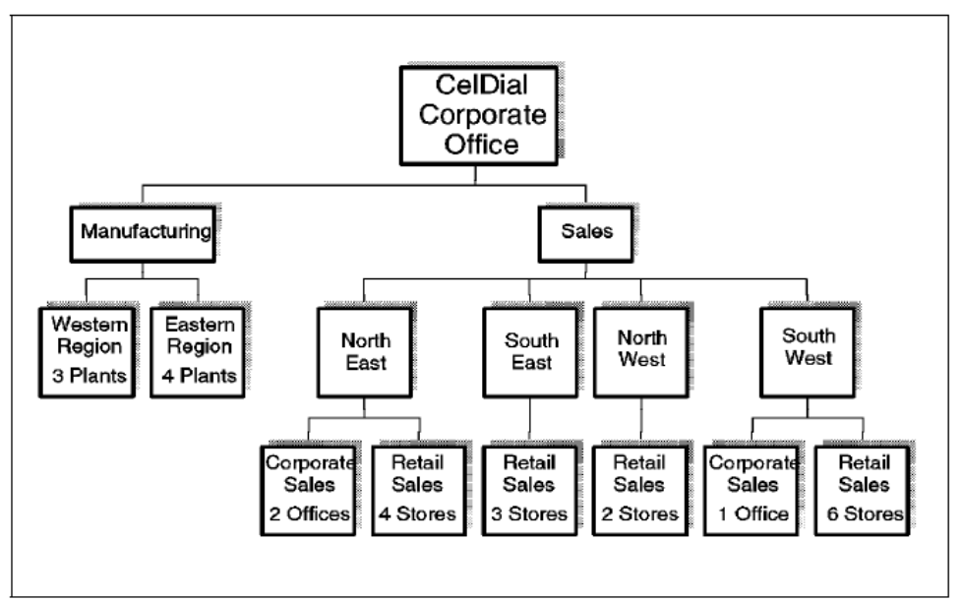

Defining cost and revenue
Cost-For every item model, the expense of every part is duplicated by the quantity of segments used to make the model. The aggregate of results for all segments that make up the model is the expense of that model. Income For every item model, the arranged unit selling cost is duplicated by the amount sold. The aggregate of results for all request lines that sell the model is the income for that model.

Design Approach:
- Choose the Data Mart: Sales, Inventory
- Declare the Grain: Date, Location
- Choose the Facts: Sales ,Inventory
- Choose the Dimensions: Date, Customer, Product, Orders, Order_details, Manufacturing_plant, Component, Sales_outlet, Salesperson, Location

Entity Details
ENTITY | FACT/DIMENSION
CUSTOMER | DIMENSION
SALESPERSON | DIMENSION
SALES | FACT
ORDER | DIMENSION
ORDE_DETAILS | DIMENSION
SALES_OUTLET | DIMENSION
INVENTORY | FACT
MANUFACTURING_PLANT | DIMENSION
PRODUCT | DIMENSION
DATE | DIMENSION
LOCATION | DIMENSION
COMPONENT | DIMENSION

ENTITY | NUMBER OF ATTRIBUTES
CUSTOMER | 3
SALESPERSON | 3
SALES | 5
ORDER | 6
ORDE_DETAILS | 5
SALES_OUTLET | 2
INVENTORY | 7
MANUFACTURING_PLANT | 3
PRODUCT | 5
COMPONENT | 5

Logical Design
Required Trace Ability Matrix
SUBJECT AREA | KEY BUSINESS MEASURES | GRANULARITY | DIFFERENT KIND OF ANALYSIS | DIMENSIONS INVOLVED IN ANALYSIS
SALES | Total revenue  Total quantity sold  Discount | Week, month  Outlet type: retail, corporate  Product type, model | - Total revenue for each model, for each region  - Percentage of products eligible for discounting  - Percentage of products sold based on outlet type.  - Products not sold this week, month  - Top five products/models by revenue, by cost, by quantity  - No sales recorded by outlet type last month  - Number of employees with no sales last month | Time  Customer  Product  Orders
INVENTORY | Total cost  Total quantity  Produced  Reorder_level | Week, month  Product type, model | - Average quantity on hand and reorder level by manufacturing plant  - Total cost for each model type, for each region | Product  Manufacturing  Time

FACT  DIME  NSION | TOTAL QTY SOLD | TOTAL QTY PRODUCED | RE-ORDER LEVEL | TOTAL REVENUE | TOTAL COST | DISCOUNT
Date | X | X | X | X | X | X
Customer |  |  |  |  |  | X
Order | X |  | X | X
Product | X | X | X | X | X | X
Manufacturing |  | X | X |  | X
Physical Design
DATA USAGE | STANDARD
DATE | DATE
CUSTOMER_ID | NUMBER(8)
CUSTOMER_NAME | VARCHAR2(20)
SHIP_ADDRESS | VARCHAR2(30)
ORDER_ID | NUMBER(8)
OUTLET_ID | VARCHAR2(8)
PRODUCT_ID | NUMBER(8)
QUANTITY_ON_HAND | NUMBER(8)
SALEPERSON_ID | NUMBER(8)
SALEPERSON_NAME | VARCHAR2(20)
TOTAL_REVENUE | NUMBER(8,2)
MANUFACTURING_ID | NUMBER(8)
QUANTITY_SOLD | NUMBER(8)
REORDER_LEVEL | NUMBER(8)
TOTAL_COST | NUMBER(8,2)

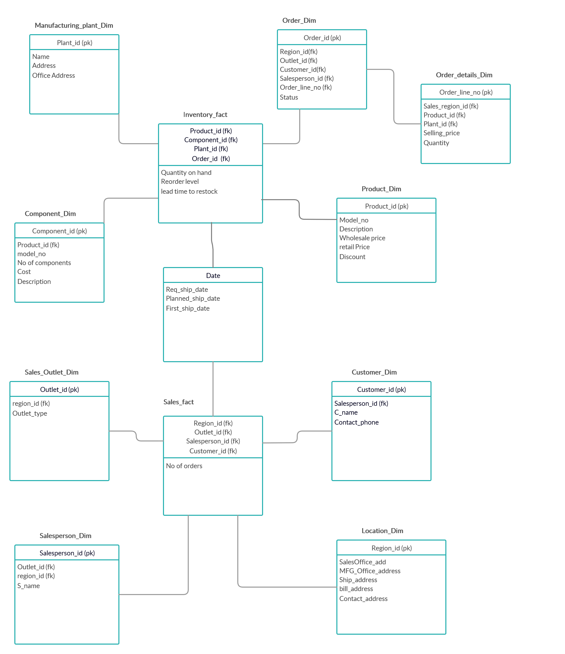

Operational to Dimensional Model - Map
Two fact tables are created as follows:
- Inventory Fact Table
- Sales Fact Table

Inventory Fact Table

This FACT table comprises of 3 DIMENSIONS: time, manufacturing_plant_region and item. The advances for this FACT table are cost, qnty_on_hand, reorder_level and to_reorder that deals with the reordering procedure as the amount close by goes underneath a pre-characterized edge.

Sales Fact Table

This FACT table comprise of 6 DIMENSIONS: date, product, sales_outlet, customer, request and manufacturing_plant_region. The exchange for this fact table comprises of cost, income, quantity_sold, discount and quantity_order. This fact table investigates the expense and income parts of the deals done in a specific time length, the markdown rate dependent on the amount of request. The fact table additionally keeps a tab of amount sold for each model.

